Documenting Practice

The case of the

HIV/AIDS/STD Prevention for Akha Population in M. Sing and M. Long

Project in Lao PDR

The project was initially developed in cooperation with Education Development Centre Inc. (EDC) which also has provided funding support through a grant from Deutche Bank. Additional funding by GTZ has supported part of the activities in Sing district. Since 2009, the project is exclusively funded by NCA.

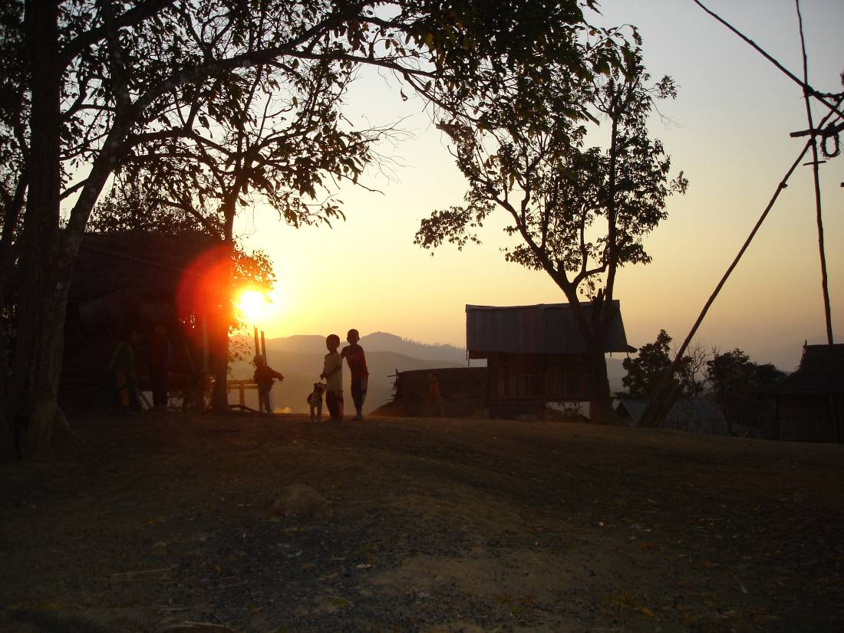

- The Initiative

The Akha are one amongst the 47 officially recognized ethnic groups in the Lao PDR. In the districts of Sing and Long in Luang Namtha province the Akha make up the majority population with over 30,000 in nearly 100 villages. Research has shown the Akha population in these districts to be at high risk of contracting HIV due to a number of interrelated factors:
- Widespread sexual networks that include multiple partners both within the Akha cultural group and from other ethnic groups including lowland Lao and Chinese.
- Young girls active sexual life with multiple partners also entailing pre puberty sexual intercourse sanctioned by the communities
- Limited access to health information and services
- A high prevalence of endemic Sexually Transmitted Infections (STI)
- No HIV prevention programs specifically targeting the Akha minority
- Few Akha speak Lao language to allow access to mainstream prevention programs.
NCA‘s Country Representation in Lao PDR concluded that this situation needed to be mitigated and the Akha communities to be empowered to deal with the risks through a culturally sensitive prevention program.

The Akha ethnic group is living in the border areas of Thailand, Burma, Laos and China and is particular vulnerable to HIV due to their widespread sexual networks that include multiple partners both within the Akha group and from other ethnic groups including lowland Lao and Chinese. Their networks also stretch across borders and the Akha is characterized by a traditionally high geographic mobility. There is limited access to preventative health information and health services and high prevalence of endemic Sexually Transmitted Infections (STIs). Before the launch of the project there were no HIV prevention programs specifically targeted to the Akha population, and few Akha people speak the Lao language which limits the ability to mainstream prevention programs.

The existing knowledge levels of HIV/AIDS, prior to the implementation of the project, amongst the Akha population in Long and Sing, ranged from very low, in roadside villages to non-existent in more remote mountain villages. While general knowledge of STIs was widespread, its spread as a sexually transmitted disease was commonly not understood. Knowledge of condoms as a means of preventing the spread for STIs was minimal; actual condom use was almost non-existent and not available in the target communities.

In this challenging context, NCA was itself well positioned to address the issue of high vulnerability to HIV/AIDS and STI amongst the Akha, due to NCA’s long standing presence among Akha communities in Long district. However, the complexity and sensitive nature of the issue required careful research prior to the design of interventions. For this purpose, NCA engaged Dr. Chris Lyttleton, Assistant Professor of Macquarie University in Sydney, and one of the leading anthropologists on ethnic minorities in Lao PDR. Dr. Lyttleton conducted the research together with the local NCA staff and Akha youth in order to get insight into the Akha sexual practices, their understanding of sexuality and the gender implications. The understanding of these interrelated issues as well as the Akha social structure has been the very foundation for the design of the project.

With most government officials being lowland Lao and unable to communicate in Akha, there has in the past been very limited interaction between the duty bearers and the rights holders. Through information campaigns and facilitation of training, in both Lao and Akha language for duty bearers (government entities, NCA and other INGOs) and rights holders, NCA has enabled the empowerment of both parties and contributed to raising awareness and reducing the risk of potential spread of HIV/AIDS and STIs.

The Akha Woods project was launched in 2005 with the overall goal of “Reducing vulnerability of HIV/AIDS/STD transmission among ethnic minority populations in Long and Sing Districts in Lao PDR”, in this context the project has implemented the following sensitive and cultural specific activities:
- Training of Akha Village Authorities and the creation of HIV resilient communities
- Peer group education activities
- Media production
- Dissemination of Media/Mobile campaigns
- STI diagnosis – treatment and prevention

In order to effectively communicate with the Akha communities a series of videos in the Akha language were produced. Producing information materials in an ethnic language is in itself a controversial undertaking due the government’s pursuit of Lao as the only language to be used for educational purposes. However, after consultations, the local authorities came to the realization that dissemination in Akha was the only feasible option for reaching the population. Local authorities have since then been very cooperative and supportive. This is in itself a great achievement which has not only enabled ethnic minority people to receive information in their own language thereby ensuring their rights to knowledge and information, but also made the government as a duty bearer aware of the advantages in communicating in the minority groups own languages.

Videos were produced with local NCA staff and Akha villagers as actors, the setting being the daily life of the local communities. Information regarding HIV and STI’s was provided through means of a soap-opera, with drama and Akha singing and dancing and raising awareness and demonstrating how to reduce the risk of transmission. The videos made in the Akha language are the first of its kind in Laos and have been widely distributed among projects working with Akha communities. Tapes with the main messages and Akha music have been distributed in large numbers in the targeted communities and are very popular and commonly brought to the local communities and listened to during the long hours of back-breaking work.

The videos are an important tool in the village outreach work and are shown during the popular night sessions for the entire community and are followed up by teams of trained Peer Educators and Outreach teams. The Outreach teams consist of project staff, local village volunteers and members of the district health department. The video showings also set the stage for the treatment of prevalent STIs in the communities. Depending on the village, people who have (or have had) suspected STI symptoms come to see the medical staff and receive treatment “on the spot”.

- The Good Practice and the Lessons Learned

In a Lao context, the Akha Woods project has been pioneering in terms of producing development communication on HIV/AIDS/STI in Akha language and in a familiar cultural context. The composition of the outreach teams has directly engaged both duty bearers and rights holders in the dissemination of information to the Akha communities. This has resulted in increased knowledge amongst Akha communities of HIV/AIDS/STI transmission and assisted them to take responsibility for reducing their risk behaviors by creating HIV/STI resilient communities.

The project would not have succeeded without a thorough understanding of the Akha culture, particularly the aspects of Akha culture which is very limited in research and documentation. The research carried out by Dr. Lyttleton prior to the design of the project insured that interventions were culturally appropriate, relevant to the context and efficient. The continuous monitoring carried out by Dr. Lyttleton has enabled the project to fine-tune activities and evolve as progress was made in the targeted communities.

This can be exemplified by changes in the practice of Akha girls pre-puberty sexual activities. Previously, the youth leaders in the community had a certain level control over these girls choice of sexual partners in accordance with old practices within the communities. These practices are now reported to be changing.

- Impacts and Results

The project has made a significant contribution to the increased knowledge amongst targeted Akha communities of HIV/AIDS/STD, and it has assisted them in taking responsibility for reducing risk behaviors. The project has through its media campaign succeeded in making the previous “invisible”
HIV/STIs diseases visible to the Akha communities’ thereby raising awareness and reducing risky behaviors.
The outreach activities have raised knowledge and contributed markedly to preventive behavior. According to project monitoring and evaluation reports, women and men of the villages are able to describe in basic terms about HIV being an infectious disease and they are familiar with the modes of transmission and methods of protection.

The media produced in the Akha language with local participants has been distributed widely and has been highly effective in raising awareness within local communities. Even in villages with no other interventions, the videos alone has brought attention to the immediate threat facing local Akha communities of the potential or real spread of HIV and other STIs. In some villages, the videos are still played weekly more than 12 months after the production, in others there is a desire for new material.

The increase in treatment of STI has been dramatic. More than 6% of the population attending outreach campaign events have been treated for STIs; amounting to more than 2% of the total population in Sing and Long Districts. To date, no Akha are known to be HIV infected.

- The Challenges

In the past four year the Akha Woods project has made considerable progress in raising awareness and changing behavior amongst Akha communities at high risk of contracting HIV/AIDS/STI. The main challenge lies in maintaining this behavior and spread the impact to the remaining Akha communities given the project very limited funding in 2009 and the uncertainty of its future beyond 2009. In addition, the project has at this stage not developed a comprehensive exit strategy.

There are still many aspects of the Akha culture and their understanding of reproductive health and indeed gender norms and practice that need to be further researched, in order for the project to develop a relevant and effective program in the future. There is a need to more actively address traditional harmful practices and reproductive health issues, which if left unattended might contravene some of the messages of the existing project.

Some initiatives to make project activities more sustainable have already been taken. For example the marketing of condoms, which are now made available at the village level through mechanisms that do not rely on free distributions. The existing health system and the sub-district dispensaries particular will be closer integrated as part of the referral system once the population becomes more confident about seeking treatment for STIs. However, the project is moving in the right direction with more of the activities becoming increasingly more sustainable.

- Potential for Replication

The Akha Woods project has been specifically designed to address the issues of HIV/AIDS/STI amongst an ethnic group with specific cultural traditions that put them at high risk of HIV/AIDS/STI transmission. However, the project approach, with its thorough contextual analysis and design of culturally appropriate activities as well as the structures put in place with the engagement of both duty bearers and rights holders, could easily be replicated elsewhere. The production of information materials in ethnic language has also proven to be important tool in reaching a population that is often left out of mainstream information campaigns, thereby ensuring them their right to information and enabling the population to make informed decision regarding vital aspects and treats to their lives.

- Contact Details

Sithonh Soundara, Project Manager: sithonh@hotmail.com
Henrik Schmith, Country Program Manager: henrik.schmith@nca.no

