REQUEST FOR QUOTATION

TO:

<Name and address> |  | Date of issue: | 15/3/2024
 |  | File no.: | 3584
 |  | Contract title: | Frame work agreement for supply and delivery of NFIs and assorted WASH items to NCA Country Office Juba Republic South Sudan
 |  | Closing date: | 15/4/2024 Time: 4:00 Pm South Sudan Local Time
 |  | For further information, please contact the Contracting Authority: | Norwegian Church Aid South Sudan Programme  Contact person: Taban Charles  E-mail: Taban.Charles@nca.no
 |  | Please note that the Quotations may be sent to the Contracting Authority at the above address by post, delivered to the Contracting Authority in a sealed envelope clearly marked with the above File Number and the name of the submitting company.

NORWEGIAN CHURCH AID nvites you to submit a quotation for the following GOODS UNDER a Framework Contract

Item | Description | Unit | Quantity | Required delivery date
Lot 1 | Shelter NFI kits | Kit | 1 | Call off basis
Lot 2 | Dignity kits | Kit | 1 | Call off basis
Lot 3 | WASH NFIs | Each | 1 | Call off basis
Lot 4 | Sanitation items | Each | 1 | Call Off basis

Instructions

The frame work agreement intends to cover a duration of one year to be used basically for NCA Emergency intervention in the Republic of South Sudan though other programmes may also use it if need be. NCA reserves the right to have two or more contracts with venders under this frame work agreement. NCA also reserves the right to have no contracts under this Frame Work Agreement. The implementation of this frame work agreement shall be through a call-Off purchase order. NCA often spend substantial amount of money every year under it emergency programme but this depends on the funding level.

- Acknowledgement
Upon receipt of the Request for Quotation please inform the Contracting Authority if you intend to submit a quotation. Please respond even if negative.

- General
The goods to be purchased are for use by the Contracting Authority in its Emergency Programme in the Republic of South Sudan, an intervention supported by Norwegian Government. The supplier can submit a quotation for one, several or all the lots.

- Cost of quotation
The supplier shall bear all costs associated with the preparation and submission of his quotation and the Contracting Authority will in no case be responsible or liable for these costs, regardless of the conduct or outcome of the negotiated procedure.

- Eligibility and qualification requirements
Suppliers are not eligible if they are in one of the situations listed in article 15 of the General Terms and Conditions for Supply Contracts.

In the Quotation Submission Form suppliers shall attest that they meet the above eligibility criteria. If required by the Contracting Authority, the supplier whose quotation is accepted shall further provide evidence satisfactory to the Contracting Authority of its eligibility through certificates issued by competent authorities in its country of establishment or operation or, if such certificates are not available, through a sworn statement.

Suppliers shall also be requested to certify that they comply with article 13. “Child Labour and Forced Labour” and article 14 “Mines” of the General Terms and Conditions for Supply Contracts and with the Code of Conduct for Contractors.

To give evidence of their capability and adequate resources Suppliers shall provide the information and the documents requested by the Contracting Authority.

- Exclusion from award of contracts
Contracts may not be awarded to Candidates who, during this procedure:

- are subject to conflict of interest:
- are guilty of misrepresentation in supplying the information required by the Contracting Authority as a condition of participation in the Contract procedure or fail to supply this information.

- Documents comprising the Request for Quotation
The Supplier shall complete and submit the following document with his quotation:

- The attached Quotation Submission Form
- Suppliers technical specifications
- Copies of any registration certificates as required by national legislation or competent authorities including company registration certificates, tax clearance certificate and membership certificates of any relevant professional bodies.
- References that we may contact for further background information of your company.
- Previous contracts for similar NFIs and Assorted WASH items that the company had supplied
- Manufacturer’s Authorization (if the supplier is not the manufacturer)

- Price
The price quoted by the supplier shall not be subject to adjustments on any account except as otherwise provided in the conditions of the Contract.

Price shall be quoted in USD.

For evaluation purpose, where quotations are given in local currency, it shall be converted into USD at the official rate published by government of the Republic of South Sudan on the closing date.

The Contracting Authority will pay the successful supplier for each purchase order issued and supplies delivered in accordance with the terms of this Request for Quotation, a sum which shall be based on the supplies ordered by the Contracting Authority and delivered by the successful supplier, at the price specified in the Contract.

The Contractor guarantees that the price specified in this Request for Quotation, is the maximum price that shall remain firm and shall not be increased during the entire term of the Contract, provided however, that in the event that the successful supplier is able to offer the Contracting Authority a discounted price on placement of bulk contracts, the unit price shall be reduced for specific contracts.

By signing this Contract, the Contractor certifies that the Contracting Authority, for transactions resulting from this Request for Quotation is not being charged more than other clients for similar supplies and similar bulk orders and within similar circumstances.

VAT and/or any sales tax applicable to the purchase of supplies shall be indicated separately in the Quotation Submission Form.

- Validity
Quotations shall remain valid and open for acceptance for 60 days after the closing date.

- Closing date
Quotation must be received by the Contracting Authority as specified on page 1 not later than the closing date and time. Any quotations received after that will not be considered.

- Award of Contract and Criteria

The Contracting Authority will award the Contract to the number of suppliers whose quotation has been determined to be substantially responsive to this Request for Quotation (RFQ), and who has offered the lowest ranked prices, provided further that the supplier has demonstrated the capability and resources to carry out the Contract effectively. And provide after sales service.

The Contracting Authority aims to purchase goods that minimise the environmental impact. Therefore, NCA reserves the right to choose a Supplier based on environmentally sustainable criteria such as packaging, life span, durability, availability of spare parts, recyclability, etc. over quotations that do not meet these standards.

The Contracting Authority reserves the right to accept all or part of your quotation, whichever is in its best financial interest.

- Signature and entry in to force of the Contract
Prior to the expiration of the period of the quotation validity, the Contracting Authority will notify the successful supplier in writing.

Within 5 days of receipt of the Contract, not yet signed by the Contracting Authority, the successful supplier must sign and date the Contract and return it, to the Contracting Authority. On signing the Contract, the successful supplier will become the Contractor and the Contract will enter into force once signed by the Contracting Authority.

If the successful supplier fails to sign and return the Contract and within the days stipulated, the Contracting Authority may consider the acceptance of the quotation to be cancelled without prejudice to the Contracting Authority's right to, claim compensation or pursue any other remedy in respect of such failure, and the successful supplier will have no claim whatsoever on the Contracting Authority.

- Cancellation for convenience
The Contracting Authority may for its own convenience and without charge or liability cancel the RFQ at any stage

Special conditions
- Scope of Supply and related services,
The subject of the contract is the supply, and delivery of the supplies described in the Price and Technical Data Form in Annex 1.

The Contractor acknowledges that:
- The Contracting Authority is not obligated to place any minimum number of purchase orders with the Contractor, pursuant to this Contract
- The Contracting Authority shall not be liable for any cost in the event that no purchase order is placed under this Contract; and
- This Contract is non-exclusive, and the Contracting Authority is entitled to procure the same or similar supplies from other Contractors, as it sees fit.

- Terms and Termination

The contract is valid for a period of 12 months, and commences on the commencement date and expires at midnight on the expiry date, unless earlier termination in accordance with the General Terms and Conditions of this contract.

The Contracting Authority shall be entitled to renegotiate the contract for a further period of 12 months on similar terms and conditions, by giving the Contractor written notice of its intention to renegotiate the contract not less than 30 days prior to the expiry date.

In the event of a breach of the contract, the Contracting Authority may terminate the contract as per General Terms and Conditions article 8 and 11.

- Confirmation of Purchase Order)
The Contract shall be implemented through purchase orders, which will be placed by the Contracting Authority according to the terms and conditions in the Contract.

The Contractor shall acknowledge receipt of a purchase order by signing and returning the purchase order within 3 working days of its receipt.

- Delivery)
The supplies shall be delivered to DDP NCA Juba Office in the Republic of South Sudan in accordance with this Contract and with the quantities and other instructions specified in the purchase order. All risk of loss or damage to the supplies shall remain with the Contractor until physical delivery takes place in accordance with the Contract.

Delivery shall not exceed 10 days from the date of receipt of a purchase order by the Contractor, and the Contractor acknowledges that lead time for delivery is defined as the time from receipt of a purchase order and the manufacturing period until supplies are available for dispatch from the point of origin.

- Payment
Payment will be made upon receipt of the following documents and within 30 days after dispatch of goods:

- Invoice (one original + two copies)
- Proof of delivery; Signed - Waybill / Delivery Note / Goods Received Note / Packing list) (one original + two copies)
- Air Way bill in (one original and three copies) or Bill of Lading in (three originals and three copies)
- Warranty Certificate (one original)
- Pre-shipment inspection Certificate (one original)
- Any other document/certificate required for import/export of supplies

- Insurance
It is the responsibility of the supplier to issue a transport insurance covering transport to point of delivery.
QUOTATION SUBMISSION FORM

Price schedule (Price and currency to be inserted by supplier)

Item | Description |  | Unit | Qty | Currency USD
 |  |  |  |  | Unit Price  DDP | Total Price DDP
Lot 1 | Shelter NFI kits
 | Components of the NFI KITs
1.1 | Reinforced Plastic sheeting, -  -Size 4Mx6M,  -Aluminium eyelets every 100cm,  -Reinforced edges  -UV treated and  -NCA logo on it  -Specifications are in line with IOM /ICRC  -8 logos; 4 on both extreme ends |  | Piece | 1
1.2 | - Fleece Blankets  -dimension: 150cm x200cm,  -2sides covered with cloth tap and other two sides sewn  -all 4 sides folded and stitched |  | Piece | 1
1.3 | Collapsible Jerry cans,  -Square model  -10 litre capacity,  -Made of food grade plastic  -Built in carrying Handle  -Screw cap linked to container |  | Piece | 1
1.4 | Plastic sleeping mats  -Family size  -180cmx270cms  -weight 2.15kgs +/-5% |  | Piece | 1
1.5 | Long-lasting Insecticidal Mosquito net,  -75 denier, polyester  -Dimension:190 cmx150cmx180cm  -Insecticide treated |  | Piece | 1
1.6 | White polytherene bags; PP bags 74cmx116cm, bottom stitched ,145gms with NCA logo on printed on both sides |  | Piece | 1
Lot 2 | Dignity Kits
 | Components of the NFI kits
2.1 | Re-usable Sanitary pads for girls and women, packed of 6 pcs. |  | Piece | 1
2.2 | Under wear for girls and women assorted sizes, assorted colours medium and large sizes |  | Piece | 1
2.3 | Laundry soap 600g |  | Bar | 1
2.4 | Bathing soap anti-bacterial, 100g |  | Piece | 1
2.5 | Kitenge for girls assorted colours, 2 yards |  | Piece | 1
2.6 | Comb with 11-13 sticks assorted colours |  | Piece | 1
2.7 | Durable Rechargeable led Solar torch, also uses power. Long life non-maintenance battery, above 200times circulating using, with super bright, long life& electricity saving LED, adopt special focus reflecting cap, the light can reach as far as 150 metres. (9 LED and 1 W. LED |  | Piece | 1
2.8 | Assorted slippers for women, different colours;38-42 sizes |  | Pair | 1
2.9 | Pegs, packed of 12 pieces |  | Set | 1
2.10 | Lawa, size 2 yards |  | Piece | 1
2.11 | Rope, cloth line 4m |  | Roll | 1
2.12 | Nail cutter |  | Piece | 1
2.13 | Sleeping mat small size 180cmx90cm |  | Piece | 1
2.14 | Packing bag made out of cloth purple in colour with handle and Zip printed with NCA Logo on it |  | Piece | 1
Lot 3 | Assorted WASH NFIs
3.1 | Plastic Bucket of 20 litre capacity with lid and tap with NCA Logo Printed on it |  | Piece | 1
3.2 | Plastic Bucket of 20litre capacity without lid with NCA logo printed on it |  | Piece | 1
3.3 | Long-lasting Insecticidal Mosquito net,  -75 denier, polyester  -Dimension:190 cmx150cmx180cm  -Insecticide treated |  | Piece | 1
3.4 | Laundry soap 600g in Bars |  | Bar | 1
3.5 | Bathing soap, anti-bacterial 100g |  | Piece | 1
3.6 | Under wear, w/elastic waisted medium size 100% cotton assorted colours but not white |  | Piece | 1
3.7 | Under wear, w/elastic waisted XL size 100% cotton assorted colours but not white |  | Piece | 1
3.8 | Sanitary Pads packed with 5 pieces (3maxi pad, 2 Supper maxi pad) |  | Packed | 1
Lot 4 | Sanitation items
4.1 | Squatting slab plastic single, 120cmx80cm |  | Each | 1
4.2 | Squatting slab double 240cmx80cm |  | Each | 1
4.3 | Rapid latrine Super structure with NCA Logo printed on (Details in Annex II attached) |  | Each | 1
4.4 | Latrine digging tool:
4.4.1 | Spade with metallic handle |  | Piece | 1
4.4.2 | Mattock with wooden handle |  | Piece | 1
4.4.3 | Pickaxe |  | Piece | 1
4.4.4 | Metallic digging Bar 5ft |  | Piece | 1
4.4.5 | Hoe with handle |  | Piece | 1
 |  | Total price 2020
 |  | Freight to NCA Juba Office
 |  | Value added tax (VAT)
 |  | Total price incl. VAT (Incoterm 2020) Juba South Suda

 | Information to be entered by supplier in the below columns
Manufacturer
Please state name of Manufacturer
After sales service and warranty service)
Please state full contact details of the local after sales service.
Delivery date
DDP Point of shipment
Delivery time to DDP Point of shipment | days
Delivery time to final destination | days
NFI Kits
Item 1: gross weight / total volume (CBM)
Reinforced Plastic sheeting | Kg CBM
Blanket | Kg CBM
10 litres collapsible Jerry can | Kg CBM
Sleeping mats | Kg CBM
Mosquito net | Kg CBM
White polytherene bag | Kg CBM
Dignity Kits
Re-usable Sanitary pad | Kg CBM
Under wear | Kg CBM
Laundry soap | Kg CBM
Bathing soap | Kg CBM
Kitenge | Kg CBM
Comb with 11-13 sticks | Kg CBM
Solar torch light | Kg CBM
Slipper | Kg CBM
Nail cutter | Kg CBM
Rope | Kg CBM
Lawa | Kg CBM
Sleeping mat | Kg CBM
Bag | Kg CBM
Assorted WASH items
Plastic Bucket of 20 litre capacity with lid and tap with NCA Logo Printed on it | Kg CBM
Plastic Bucket of 20litre capacity without lid with NCA logo printed on it
Sanitation items
Squatting slab single
Squatting slab double
Rapid latrine Super structure with NCA Logo printed on
Spade
Mattock
Pickaxe
Metal Bar
Hoe with handle
Technical specification
Complete technical description is attached (Y/N)
References
A reference list is attached
CSR information
Does your company have CSR related policies in place – e.g. health and safety policy, HR policy, staff policy, energy policy, climate policy or is a member of Global Compact. Please state which policies.
Is your company e.g. ISO 26000/50001/14001 certified or SA8000 certified? Please state which.
Does your company have a Code of Conduct?
Does your company have reverse Logistics scheme in place
Availability of after sale services
Please specify and enclose any quality accreditation - ISO 9000 2000 or equivalent held by the manufacturer of the offered products)

Suppliers are requested to complete the following form
The following technical specifications are provided in the format of a checklist. They are compulsory as minimum standard and will be the only basis for the Contracting Authority to assess the technical compliance of the equipment presented in the quotations. Deviations from the specifications may be considered only if deemed to be in the best interest of the Contracting Authority.

Manufacturers’ names, catalogue numbers and model designations appearing in the list are for reference only. Quotations for other equipment that is equal in function, quality and performance to that listed will be given full consideration.

technical data form Annex 1

Item no.: | Parameter | Characteristics (Contracting Authorities minimum requirement) | Comply (Y / N) | Deviations, if any, to be described in this column
Lot 1 | Description | Shelter NFI kits
 | Reinforcement plastic sheet | Reinforced Plastic sheeting, -  -Size 4Mx6M,  -Aluminium eyelets every 100cm,  -Reinforced edges  -UV treated and  -NCA logo on it  -Specifications are in line with IOM /ICRC  -8 logos; 4 on both extreme ends
 | Blanket | - Fleece Blankets  -dimension: 150cm x200cm,  -2sides covered with cloth tap and other two sides sewn  -all 4 sides folded and stitched
 | Collapsible Jerry can | Collapsible Jerry cans,  -Square model  -10 litre capacity,  -Made of food grade plastic  -Built in carrying Handle  -Screw cap linked to container
 | Sleeping mat | -Plastic sleeping mats  -Family size  -180cmx270cms  -weight 2.15kgs +/-5%
 | Mosquito net | - Long-lasting Insecticidal Mosquito nets,  -75 denier, polyester  -Dimension:190 cmx150cmx180cm  -Insecticide treated
 | PP bag | - White polytherene bags; PP bags 74cmx116cm, bottom stitched ,145gms with NCA logo on printed on both sides
Lot 2 | Kits | Dignity kits
 | Re-usable sanitary pads | Re-usable Sanitary pads for girls and women in pack of six pieces
 | Undwe wear | Under wear for girls and women assorted sizes; assorted colours black and grey medium and large sizes
 | Laundry soap | Laundry soap 600g in bars
 | Bathing soap | Bathing soap, anti baterial100g
 | Kitenge | Kitenge for girls assorted colours; 2 yards, 100% cotton material
 | Comb | Comb with 11-13 sticks assorted colours
 | Solar Torch | Durable Solar torch light, also uses power rechargeable with lithium-ion battery
 | Sleeping Mat | Sleeping mat small size 180cmx90cm
 | Nail cutter | Nail cutter, stainless steel
 | Rope | Rope, cloth line 4m
 | Peg | Pegs, packed of 12 pieces
 | Lawa | Lawa, size 2 yards
 | Assorted slippers | Assorted slippers for women, different colours, 38-42 sizes
 | Packaging bag | Packing bag made of durable cloth materials purple in colour with handle and Zip printed with NCA Logo on it
Lot 3 | Assorted items | Assorted WASH NFIs
 | Bucket | Plastic Bucket of 20 litre capacity with lid and tap with NCA Logo Printed on it
 | Bucket | Plastic Bucket of 20litre capacity without lid with NCA logo printed on it
 | Mosquito net | Long-lasting Insecticidal Mosquito nets. 190cmx180cmx150cm ,75denier, polyester.
 | Laundry soap | Laundry soap 600g in Bars
 | Bathing soap | Bathing soap, anti-bacterial 100g
 | Under Wear | Under wear, w/elastic waisted medium size 100 cotton assorted colours but not white
 | Under Wear | Under wear, w/elastic waisted XL size 100 cotton assorted colours but not white
 | Sanitary pads | Sanitary Pads packed with 5 pieces (3maxi pad, 2 Supper maxi pad)
Lot 4 | Sanitary items
 |  | Squatting plate plastic double 240cmx80cm
 |  | Squatting slabs single, Plastic 120cmx80cm
 |  | Rapid latrine Super structure with NCA Logo printed on (specifications attached Annex II)
 | Latrine digging tool:
 |  | Spade with metallic handle
 |  | Mattock with wooden handle
 |  | Pick axe
 |  | Metallic digging Bar 5ft
 |  | Hoe with wooden handle

N6B: samples shall be required during the evaluation process.

Annex II Duo latrine structure technical specifications:

Item | Quantity | Description
 |  | Latrine Cubicle (Duo) with Roof, comprising
1 | 1 | Left squatting plates 1.20x0.8x0.30(M)
2 | 1 | Right squatting plates 1.20x0.8x0.30(M)
3 | 1 | Partition wall panel
4 | 1 | Right rear corner panel
5 | 1 | Right front corner panel
6 | 1 | Left back wall panel
7 | 1 | Right back wall panel
8 | 1 | Left side wall panel
9 | 1 | Right side wall panel
10 | 1 | Door Panel
11 | 1 | Left roof panel
12 | 1 | Right roof panel
 |  | Accessories Bag
1 | 70 | M8x25 bolt with flat head
2 | 4 | M8x40 bolt with flat head
3 | 8 | M8 x70 bolt with flat head
4 | 82 | N8 nut
5 | 8 | ‘’L” Shaped bracket
6 | 1 | Assembling Instruction Manual
7 | 2 | No. 13 Socket spanner
8 | 2 | 3’’ Screwdriver
 |  | Packing List for Shipment
1 |  | Dimensions: 1.85x1.25x0.25m
2 |  | Net weight: 65.00 Kg
3 |  | HS Code: 3925900000
 |  | Pictures of the structure
 | 1 | 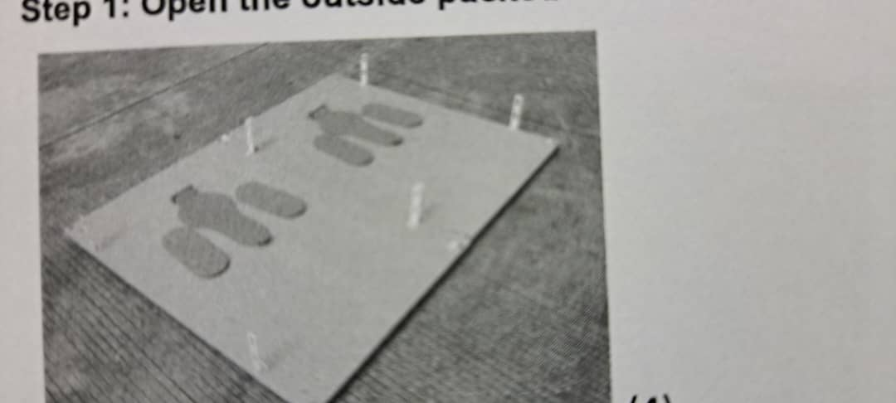
 | 2 | 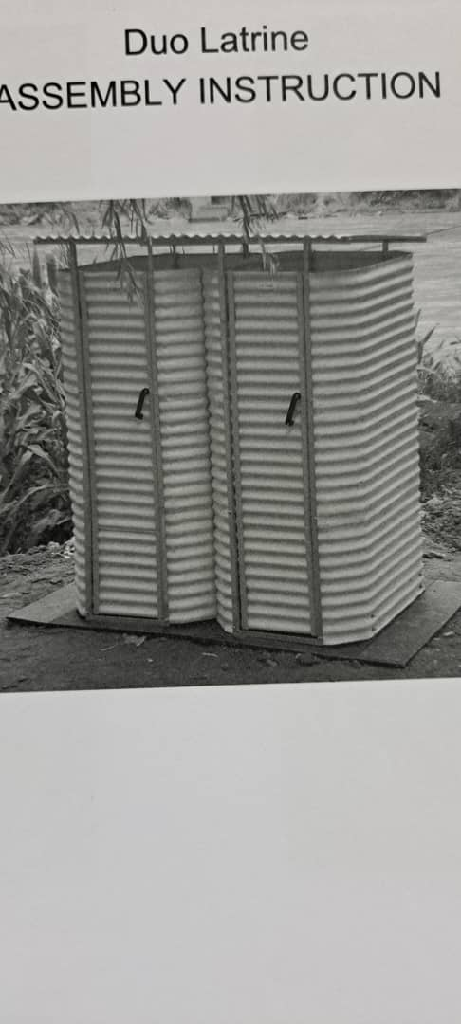

Any subsequent procurement related to this Quotation will be subject to the Contracting Authorities General Terms and Conditions for Supply Contracts and the Code of Conduct for Contractors available through the below link. Printed versions are available on request.

https://www.kirkensnodhjelp.no/en/about-nca/for-contractors/

After having read this Request for Quotation 3584 on behalf of my company/business, I hereby:

- Accept, without restrictions, all the provisions in the Request for Quotation including General Terms and Conditions for Supply Contracts with annexes.

- Provided that a contract is issued by the Contracting Authority we hereby commit to furnish any or all items at the price offered and deliver same to the designated points within the delivery time stated above.

- Certify and attest that we meet the eligibility criteria stated in the Instructions.

- Certify and attest compliance with the Code of Conduct for Contractors.

This declaration will be confirmed in the Contract and misrepresentation will be regarded as grounds for termination.

Signature and stamp:
Signed by:

The Contractor
Name of the company
Address
Telephone no.
E-mail:
Name of contact person
Date:

